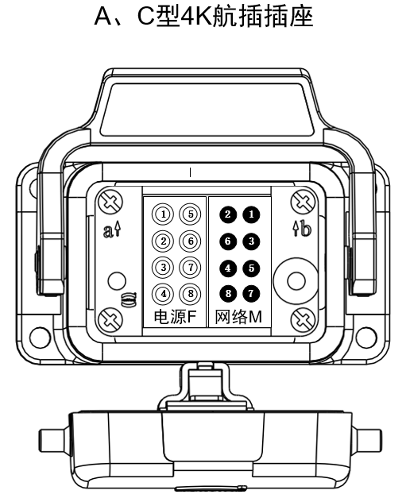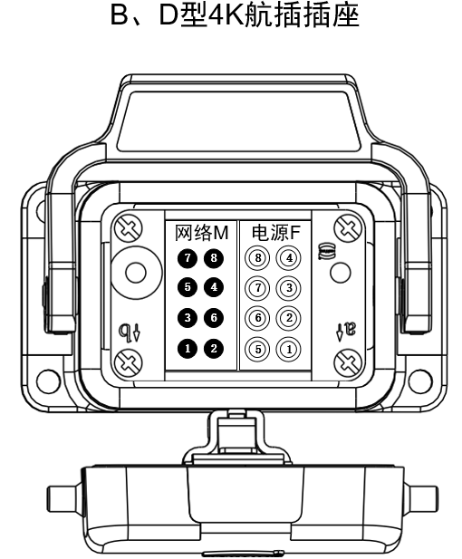

图1-5 组件插座

|  |  |  |  |
| --- | --- | --- | --- |
| **组件插座接口定义** | | | |
| **模块** | **针脚** | **定义** | **线颜色** |
| 电源 | 1 | +24V | 红 |
| 2 | -24V | 黑 |
| 3 | A+ | 棕 |
| 4 | A- | 绿 |
| 5 | GND | 橙 |
| 网络 | 1 | 网线定义568B | 橙白 |
| 2 | 橙 |
| 3 | 绿白 |
| 4 | 蓝 |
| 5 | 蓝白 |
| 6 | 绿 |
| 7 | 棕白 |
| 8 | 棕 |